**Q:1** Generate a model in Python for representation of a bank account of type savings and balance along with transactions of deposit and withdrawals and currently create a program to generate 100 accounts with Random balance and transactions for no. of months and no. Of transactions with a seed value of amount. Print all 100 accounts with the last balance and organize them from lowest to highest balance.

**Solution:** Bank Account Model with Random Transactions

Here I created a Python model to represent a savings bank account, simulate 100 accounts with random balances and transactions, and then sort them based on the final balance.

**Code:**

|  |
| --- |
| **import random**    **class BankAccount:**  **def __init__(self, account_id, balance=0):**  **self.account_id = account_id**  **self.balance = balance**  **self.transactions = []**    **def deposit(self, amount):**  **self.balance += amount**  **self.transactions.append(('Deposit', amount))**    **def withdraw(self, amount):**  **if amount <= self.balance:**  **self.balance -= amount**  **self.transactions.append(('Withdraw', amount))**  **else:**  **print(f"Account {self.account_id} has insufficient funds for withdrawal")**    **def __str__(self):**  **return f"Account ID: {self.account_id}, Balance: {self.balance}, Transactions: {self.transactions}"**    **# Generate 100 accounts with random transactions**  **accounts = []**  **random.seed(100)**    **for i in range(100):**  **balance = random.randint(1000, 10000) # Initial random balance**  **account = BankAccount(account_id=i+1, balance=balance)**    **# Simulate transactions for random months**  **num_transactions = random.randint(5, 15) # Random number of transactions**  **for _ in range(num_transactions):**  **transaction_type = random.choice(['Deposit', 'Withdraw'])**  **amount = random.randint(100, 2000)**  **if transaction_type == 'Deposit':**  **account.deposit(amount)**  **else:**  **account.withdraw(amount)**    **accounts.append(account)**    **# Sort accounts by balance**  **sorted_accounts = sorted(accounts, key=lambda x: x.balance)**    **# Display sorted accounts**  **for account in sorted_accounts:**  **print(account)** |

Output:

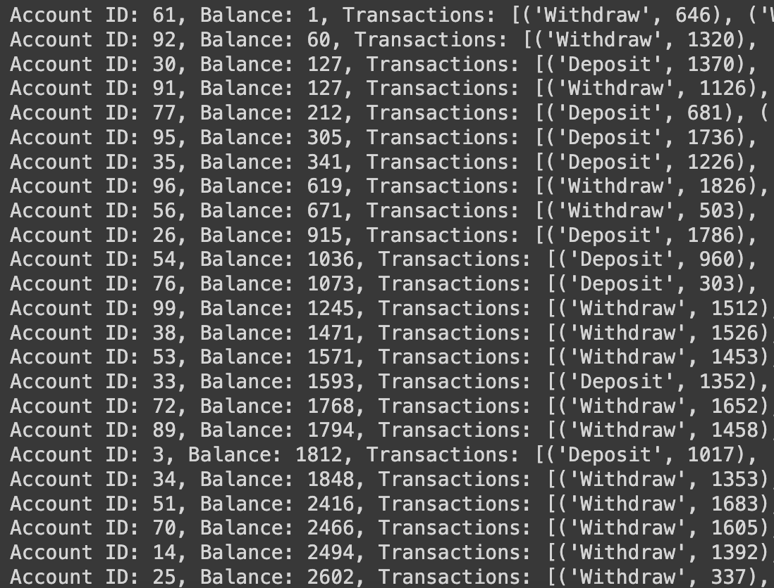

This is the small sample of the output

**Q:2** Generate a model in Python to represent a Housing loan scheme and create a chart to display the Emi based on rate of interest and reducing balance for a given period. If a customer wishes to close the loan earlier, print the interest lost distributed over the remaining no. Of months. Assume suitable data and inputs as necessary.

**Solution:** Housing Loan EMI and Early Closure Interest Calculation

Here I simulated a housing loan EMI calculation based on reducing balance and calculate the interest lost if the loan is closed early.

**Code:**

|  |
| --- |
| **import matplotlib.pyplot as plt**    **class HousingLoan:**  **def __init__(self, principal, rate_of_interest, tenure_years):**  **self.principal = principal**  **self.rate_of_interest = rate_of_interest / 100 # Convert to decimal**  **self.tenure_years = tenure_years**  **self.tenure_months = tenure_years * 12**  **self.emi = self.calculate_emi()**    **def calculate_emi(self):**  **monthly_rate = self.rate_of_interest / 12**  **emi = (self.principal * monthly_rate * ((1 + monthly_rate) ** self.tenure_months)) / (((1 + monthly_rate) ** self.tenure_months) - 1)**  **return emi**    **def early_closure_interest_loss(self, closed_months):**  **paid_months = self.tenure_months - closed_months**  **outstanding_balance = self.principal**  **total_interest_paid = 0**    **# Simulate EMI payments for paid months**  **for _ in range(paid_months):**  **interest = outstanding_balance * (self.rate_of_interest / 12)**  **principal_repaid = self.emi - interest**  **outstanding_balance -= principal_repaid**  **total_interest_paid += interest**    **total_interest_saved = (self.emi * self.tenure_months) - total_interest_paid**  **return total_interest_saved**    **def plot_emi(self):**  **balance = self.principal**  **months = []**  **balances = []**  **for month in range(1, self.tenure_months + 1):**  **interest = balance * (self.rate_of_interest / 12)**  **principal_repaid = self.emi - interest**  **balance -= principal_repaid**  **months.append(month)**  **balances.append(balance)**    **plt.plot(months, balances)**  **plt.title("Housing Loan Reducing Balance")**  **plt.xlabel("Months")**  **plt.ylabel("Balance")**  **plt.show()**    **# Example Usage**  **loan = HousingLoan(principal=500000, rate_of_interest=7, tenure_years=20)**  **print(f"EMI: {loan.emi:.2f}")**  **loan.plot_emi()**    **# Early closure after 10 years**  **months_closed = 10 * 12**  **interest_saved = loan.early_closure_interest_loss(months_closed)**  **print(f"Interest saved if loan closed after {months_closed} months: {interest_saved:.2f}")** |

**Output:**

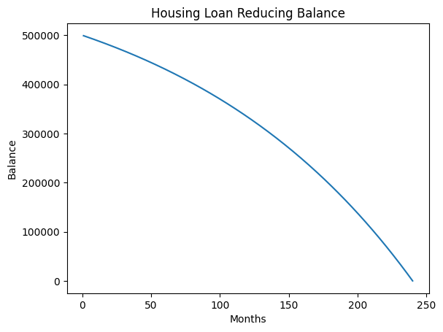**zx**